**WEB BÁN LINH KIỆN MÁY TÍNH**

**DETAIL DESIGN DOCUMENT**

**Data design**

**Project Code:**

**Document Code: WebBanLinhKienMayTinh -21/11/2017 – v1.0**

Ho Chi Minh, 21/111/2017

**RECORD OF CHANGE**

#### *A - Added M - Modified D – Deleted

|  |  |  |  |  |
| --- | --- | --- | --- | --- |
| Effective Date | Changed Items | A* M, D | Change Description | New Version |
| 21/11/2017 | Create new document. | A |  | 1.0 |
|  |  |  |  |  |
|  |  |  |  |  |
|  |  |  |  |  |
|  |  |  |  |  |
|  |  |  |  |  |
|  |  |  |  |  |
|  |  |  |  |  |
|  |  |  |  |  |
|  |  |  |  |  |

**SIGNATURE PAGE**

**ORIGINATOR:** Phạm Vũ Hoàng Phượng 21/11/2017

**REVIEWERS:** Trần Trí Tín 21/11/2017

**APPROVAL:**

**MỤC LỤC**

Contents

MÔ HÌNH DỮ LIỆU QUAN HỆ 6

1 DATABASE 7

**1.1 Products 8**

**1.2 Images 9**

**1.3 Banners 10**

**1.4 GroupCategories 11**

**1.5 Category 12**

**1.6 OrderDetail 13**

**1.7 Orders 14**

**1.8 Admin_Users 15**

**1.9 Users 16**

# 

# MÔ HÌNH DỮ LIỆU QUAN HỆ

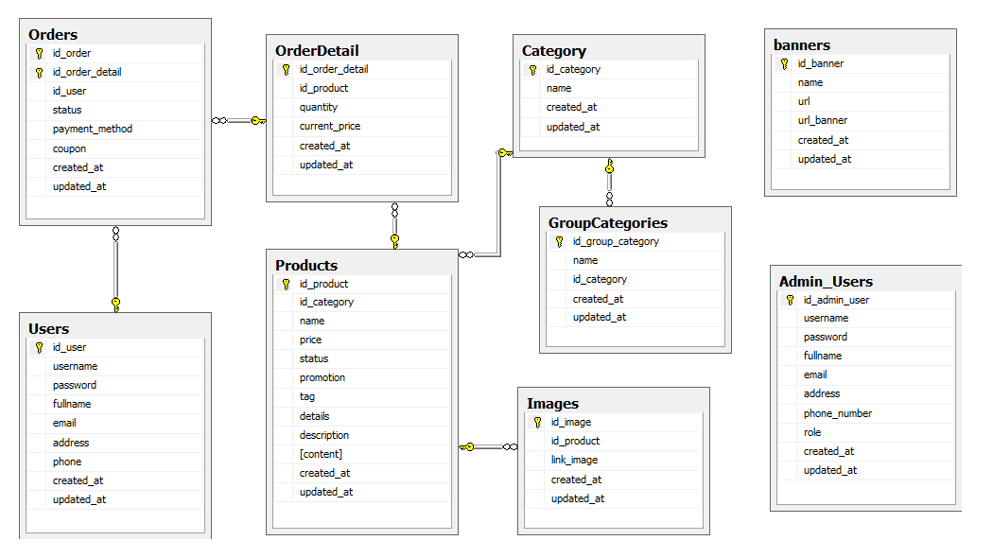

1. **DATABASE**

|  |  |  |
| --- | --- | --- |
| **No** | **Table Name** | **Description** |
| 1 | Products | Manage all products. |
| 2 | Images | Manage product images. |
| 3 | Banners | Manage slide show. |
| 4 | GroupCategories | Manage group category. |
| 5 | Category | Manage customer’s products order. |
| 6 | OrderDetail | Manage all category. |
| 7 | Orders | Manage order details. |
| 8 | Admin_Users | Manage employee users. |
| 9 | Users | Manage customer users. |

## Products

|  |  |  |  |  |  |  |  |  |  |  |
| --- | --- | --- | --- | --- | --- | --- | --- | --- | --- | --- |
| **No** | **Field Name** | **Type** | **Length** | **Size** | **Null** | **Unique** | **P/F Key** | **Default** | **Check** | **Description** |
| 01 | id_product | int |  |  |  | x | P |  |  | Auto number |
| 02 | id_category | int |  |  |  |  | F |  |  |  |
| 03 | name | nvarchar | 100 |  | x |  |  |  |  |  |
| 04 | price | float |  |  |  |  |  |  |  |  |
| 05 | status | int |  |  |  |  |  |  |  |  |
| 06 | promotion | varchar | 255 |  |  |  |  |  |  |  |
| 07 | tag | varchar | 255 |  |  |  |  |  |  |  |
| 08 | details | text |  |  |  |  |  |  |  |  |
| 09 | description | text |  |  |  |  |  |  |  |  |
| 10 | content | text |  |  |  |  |  |  |  |  |
| 11 | created_at | datetime |  |  | x |  |  | x |  |  |
| 12 | updated_at | datetime |  |  | x |  |  | x |  |  |

## Images

|  |  |  |  |  |  |  |  |  |  |  |
| --- | --- | --- | --- | --- | --- | --- | --- | --- | --- | --- |
| **No** | **Field Name** | **Type** | **Length** | **Size** | **Null** | **Unique** | **P/F Key** | **Default** | **Check** | **Description** |
| 01 | id_image | int |  |  |  | x | P |  |  | Auto number |
| 02 | id_product | int |  |  |  |  |  |  |  |  |
| 03 | link_image | text |  |  |  |  |  |  |  |  |
| 04 | created_at | datetime |  |  | x |  |  | x |  |  |
| 05 | updated_at | datetime |  |  | x |  |  | x |  |  |

* 1. **Banners**

|  |  |  |  |  |  |  |  |  |  |  |
| --- | --- | --- | --- | --- | --- | --- | --- | --- | --- | --- |
| **No** | **Field Name** | **Type** | **Length** | **Size** | **Null** | **Unique** | **P/F Key** | **Default** | **Check** | **Description** |
| 01 | id_banner | int |  |  |  | x | P |  |  | Auto number |
| 02 | name | nvarchar | 255 |  |  |  |  |  |  |  |
| 03 | url | text |  |  |  |  |  |  |  |  |
| 04 | url_banner | text |  |  |  |  |  |  |  |  |
| 05 | created_at | datetime |  |  | x |  |  | x |  |  |
| 06 | updated_at | datetime |  |  | x |  |  | x |  |  |

* 1. **GroupCategories**

|  |  |  |  |  |  |  |  |  |  |  |
| --- | --- | --- | --- | --- | --- | --- | --- | --- | --- | --- |
| **No** | **Field Name** | **Type** | **Length** | **Size** | **Null** | **Unique** | **P/F Key** | **Default** | **Check** | **Description** |
| 01 | id_group_category | int |  |  |  | x | P |  |  | Auto number |
| 02 | id_category | int |  |  |  |  | F |  |  |  |
| 03 | name | nvarchar | 50 |  |  |  |  |  |  |  |
| 04 | created_at | datetime |  |  | x |  |  | x |  |  |
| 05 | updated_at | datetime |  |  | x |  |  | x |  |  |

## Category

|  |  |  |  |  |  |  |  |  |  |  |
| --- | --- | --- | --- | --- | --- | --- | --- | --- | --- | --- |
| **No** | **Field Name** | **Type** | **Length** | **Size** | **Null** | **Unique** | **P/F Key** | **Default** | **Check** | **Description** |
| 01 | id_category | int |  |  |  | x | P |  |  | Auto number |
| 02 | name | nvarchar | 50 |  |  |  |  |  |  |  |
| 03 | created_at | datetime |  |  | x |  |  | x |  |  |
| 04 | updated_at | datetime |  |  | x |  |  | x |  |  |

* 1. **OrderDetail**

|  |  |  |  |  |  |  |  |  |  |  |
| --- | --- | --- | --- | --- | --- | --- | --- | --- | --- | --- |
| **No** | **Field Name** | **Type** | **Length** | **Size** | **Null** | **Unique** | **P/F Key** | **Default** | **Check** | **Description** |
| 01 | id_order_detail | Int |  |  |  |  | P |  |  | Auto number |
| 02 | Id_product | Int |  |  |  |  | F |  |  |  |
| 03 | quantity | int |  |  | x |  |  |  |  |  |
| 04 | current_price | float |  |  |  |  |  |  |  |  |
| 05 | created_at | datetime |  |  | x |  |  | x |  |  |
| 06 | updated_at | datetime |  |  | x |  |  | x |  |  |

* 1. **Orders**

|  |  |  |  |  |  |  |  |  |  |  |
| --- | --- | --- | --- | --- | --- | --- | --- | --- | --- | --- |
| **No** | **Field Name** | **Type** | **Length** | **Size** | **Null** | **Unique** | **P/F Key** | **Default** | **Check** | **Description** |
| 01 | id_order | int |  |  |  | x | P |  |  |  |
| 02 | id_order_detail | Int | 50 |  |  |  | P, F |  |  |  |
| 03 | Id_user | Int |  |  |  |  | F |  |  |  |
| 04 | Stutus | int |  |  |  |  |  |  |  |  |
| 05 | Payment_method | Int |  |  |  |  |  |  |  |  |
| 06 | coupon | varchar | 6 |  |  |  |  |  |  |  |
| 03 | created_at | datetime |  |  | x |  |  | x |  |  |
| 04 | updated_at | datetime |  |  | x |  |  | x |  |  |

* 1. **Admin_Users**

|  |  |  |  |  |  |  |  |  |  |  |
| --- | --- | --- | --- | --- | --- | --- | --- | --- | --- | --- |
| **No** | **Field Name** | **Type** | **Length** | **Size** | **Null** | **Unique** | **P/F Key** | **Default** | **Check** | **Description** |
| 01 | id_admin_user | int |  |  |  | x | P |  |  | Auto number |
| 02 | usename | varchar | 20 |  |  |  |  |  |  |  |
| 03 | Password | varchar | 30 |  |  |  |  |  |  |  |
| 04 | Fullname | nvarchar | 50 |  |  |  |  |  |  |  |
| 05 | Email | varchar | 255 |  |  | x |  |  |  |  |
| 06 | Address | text |  |  |  |  |  |  |  |  |
| 07 | Phone_number | Int |  |  |  |  |  |  |  |  |
| 08 | role | varchar | 255 |  |  |  |  |  |  |  |
| 09 | created_at | datetime |  |  | x |  |  | x |  |  |
| 10 | updated_at | datetime |  |  | x |  |  | x |  |  |

* 1. **Users**

|  |  |  |  |  |  |  |  |  |  |  |
| --- | --- | --- | --- | --- | --- | --- | --- | --- | --- | --- |
| **No** | **Field Name** | **Type** | **Length** | **Size** | **Null** | **Unique** | **P/F Key** | **Default** | **Check** | **Description** |
| 01 | id_user | int |  |  |  | x | P |  |  | Auto number |
| 02 | usename | varchar | 20 |  |  |  |  |  |  |  |
| 03 | Password | varchar | 30 |  |  |  |  |  |  |  |
| 04 | Fullname | nvarchar | 50 |  |  |  |  |  |  |  |
| 05 | Email | varchar | 255 |  |  | x |  |  |  |  |
| 06 | Address | text |  |  |  |  |  |  |  |  |
| 07 | Phone | int |  |  |  |  |  |  |  |  |
| 08 | created_at | datetime |  |  | x |  |  | x |  |  |
| 09 | updated_at | datetime |  |  | x |  |  | x |  |  |